Map 3 – Common Goldeneye in Late Fall 2013

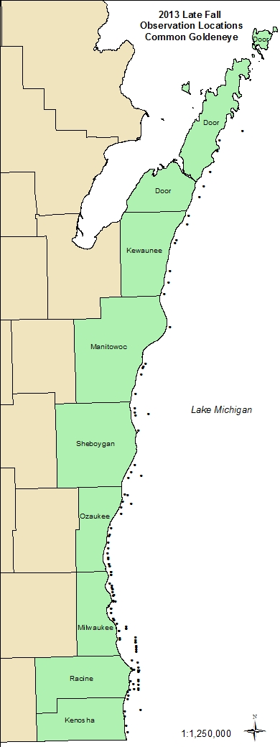

Map 4 – Ducks; Unknown Species; Early Fall 2013

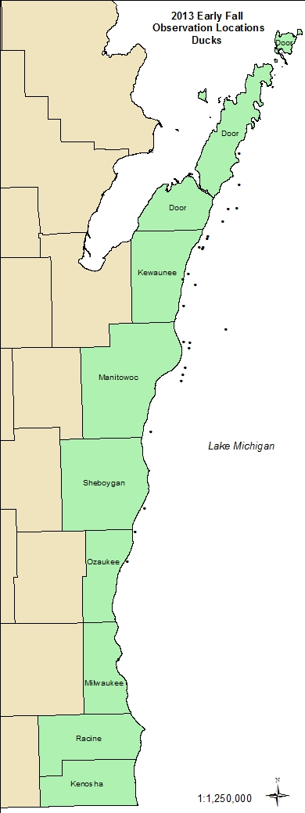

Map 5 – Ducks, Unknown Species; Late Fall 2013

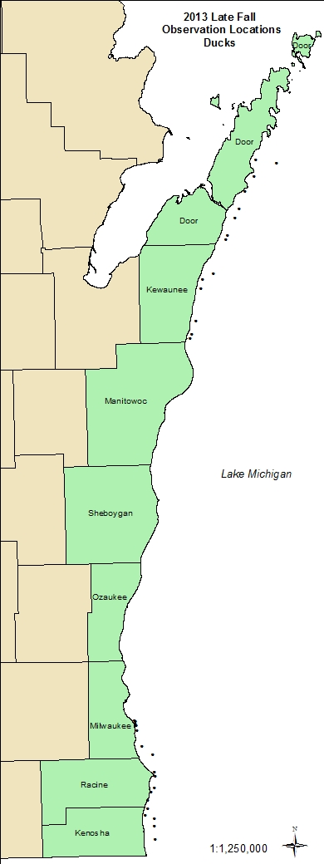

Map 6 – Most Abundant Species - Early Fall 2013

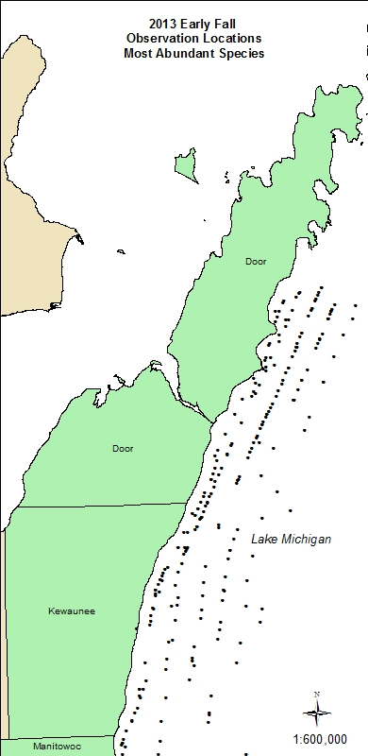

Map 7 – Most Abundant Species – Early Fall 2013

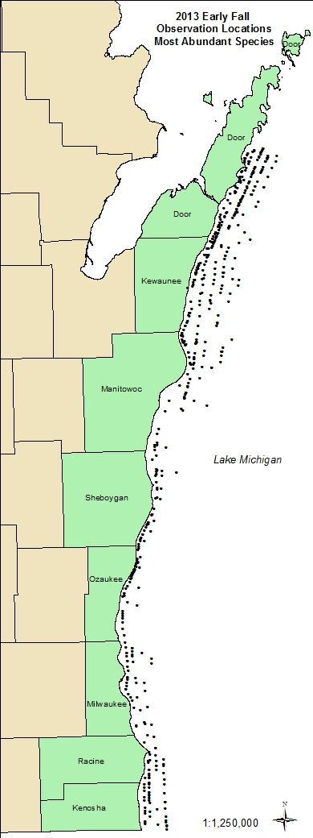

Map 8 – Most Abundant Species – Early Fall – Mid-Lakeshore

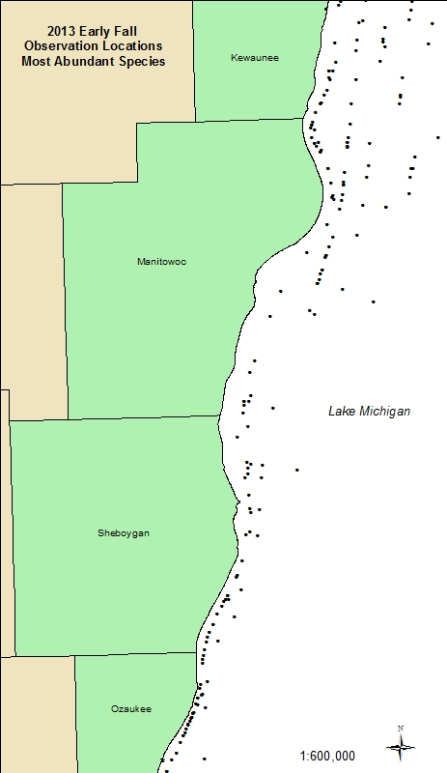

Map 9 – Most Abundant Species – Milwaukee/Ozaukee Counties

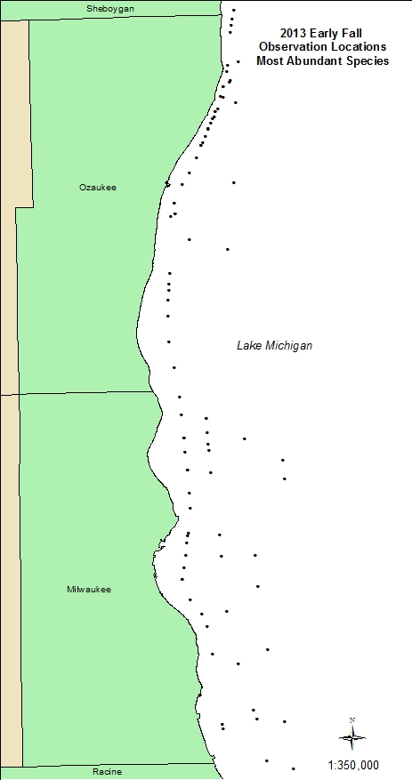

Map 10 – Most Abundant Species – Southern Counties

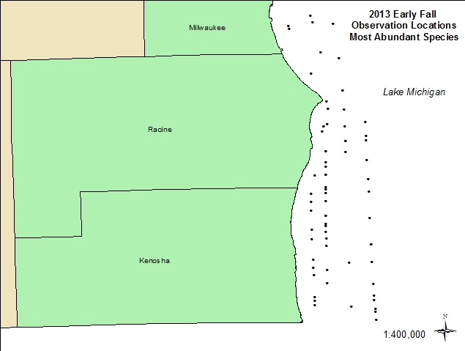

Map 11 – Gull Species (POOLED) Observations – Early Fall 2013

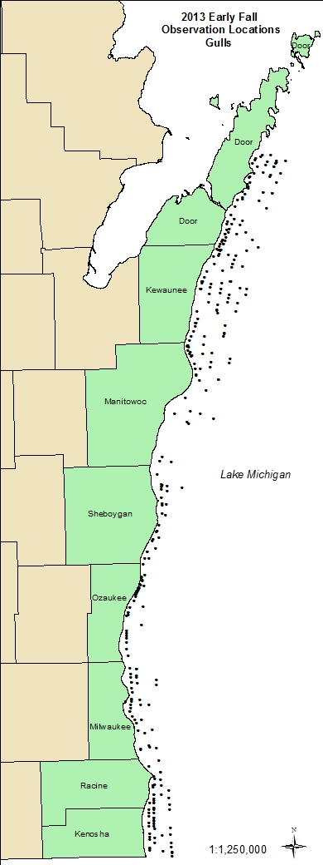

Map 12 – Gull Species (POOLED) – Graduated Circle Map – Fall 2013

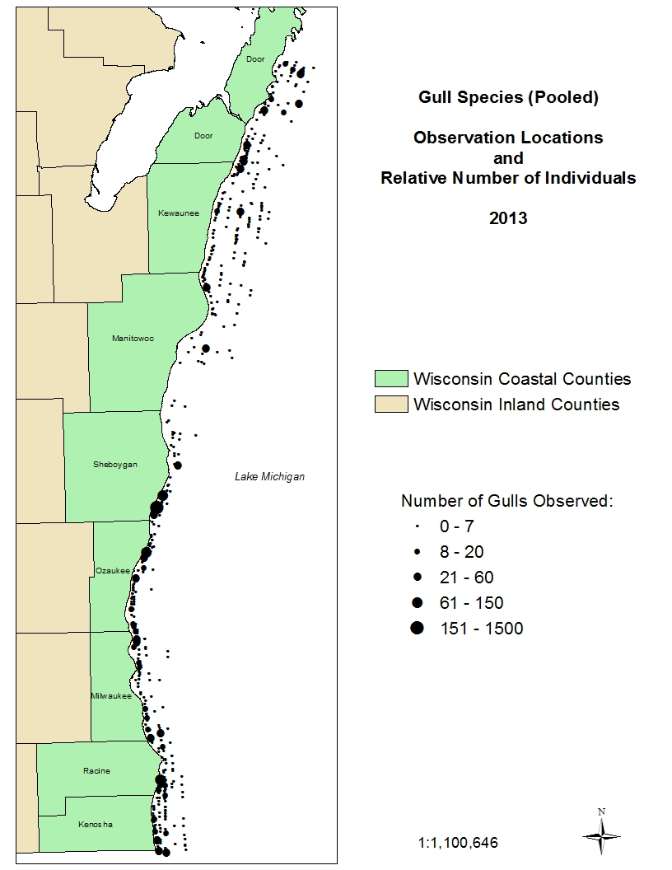

Map 13 – Gull Species (POOLED) Observations – Late Fall 2013

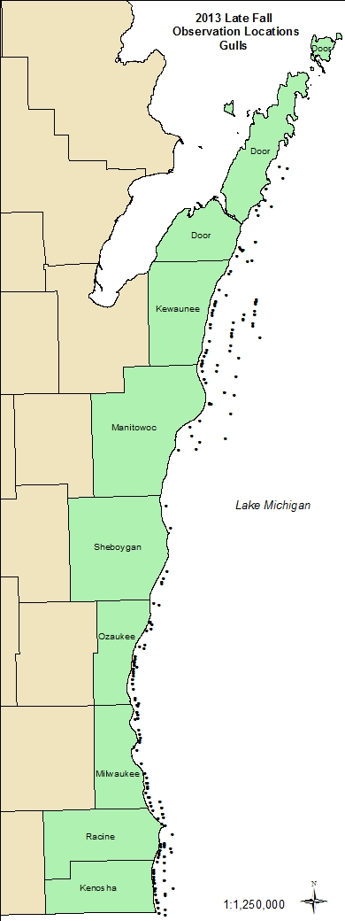

Map 14 – Most Abundant Species – Late Fall 2013 – Northern Counties

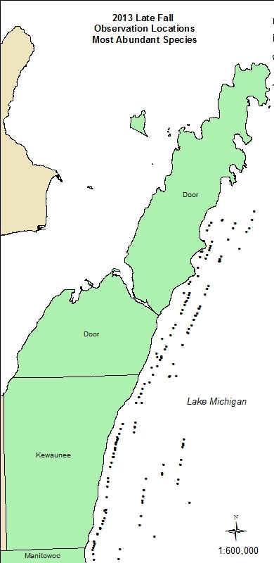

Map 15 – Most Abundant Species - Late Fall 2013

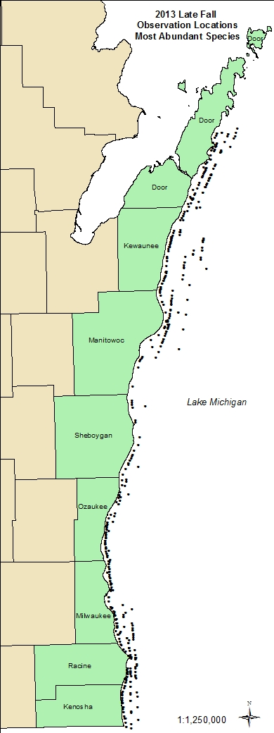

Map 16 – Most Abundant Species – Late Fall 2013 – Mid-Lakeshore

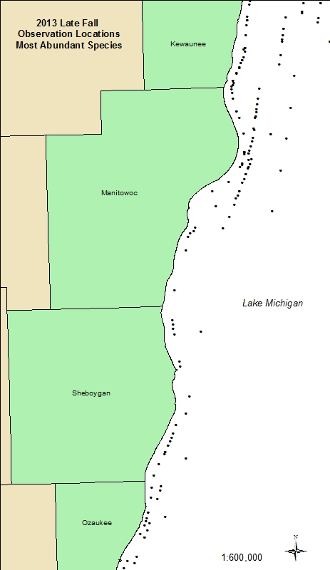

Map 17 – Most Abundant Species – Late Fall 2013 – Ozaukee/Millwaukee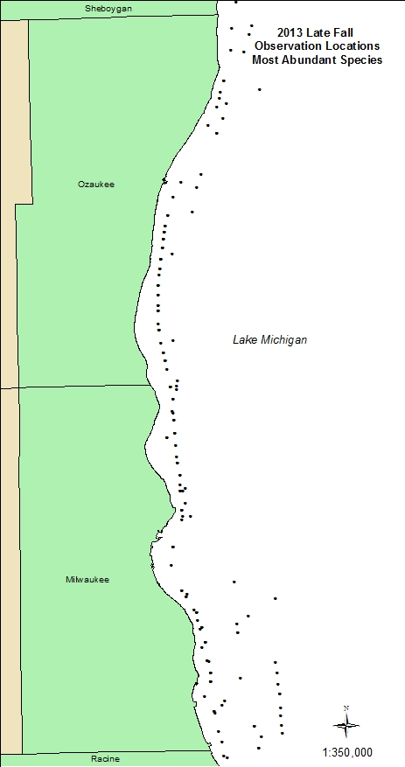

Map 18 –Most Abundant Species - Late Fall 2013 – Southern Counties

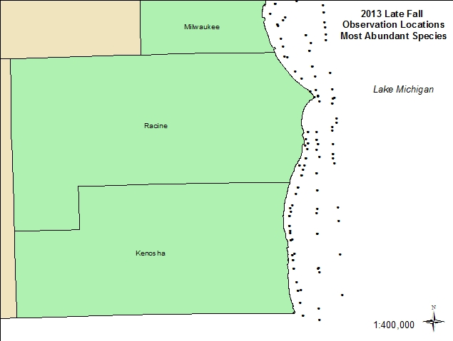

Map 19 – Loons – Early Fall 2014

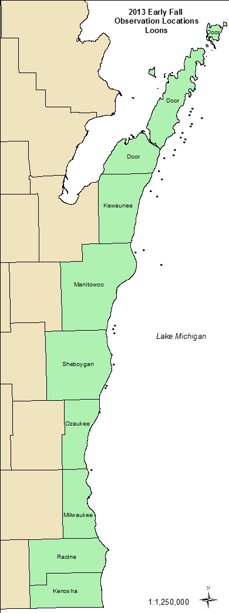

Map 20 – Fall 2013 – LTDU and Bathymetry

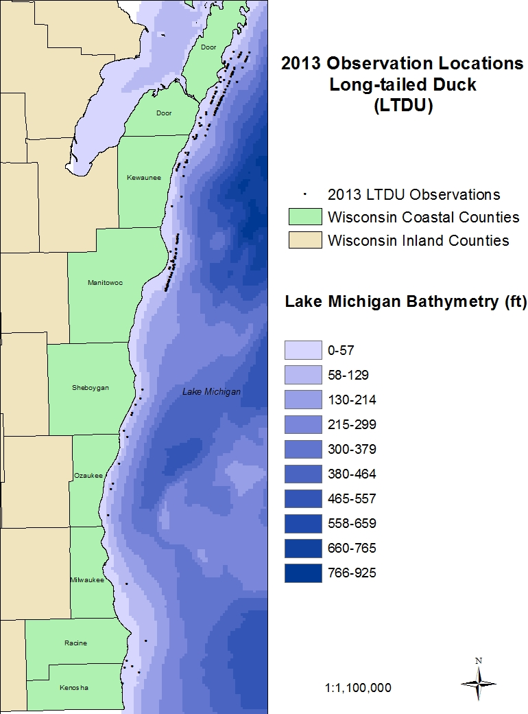

Map 21 – Fall 2013 – LTDU and Bathymetry – Mid-Lakeshore

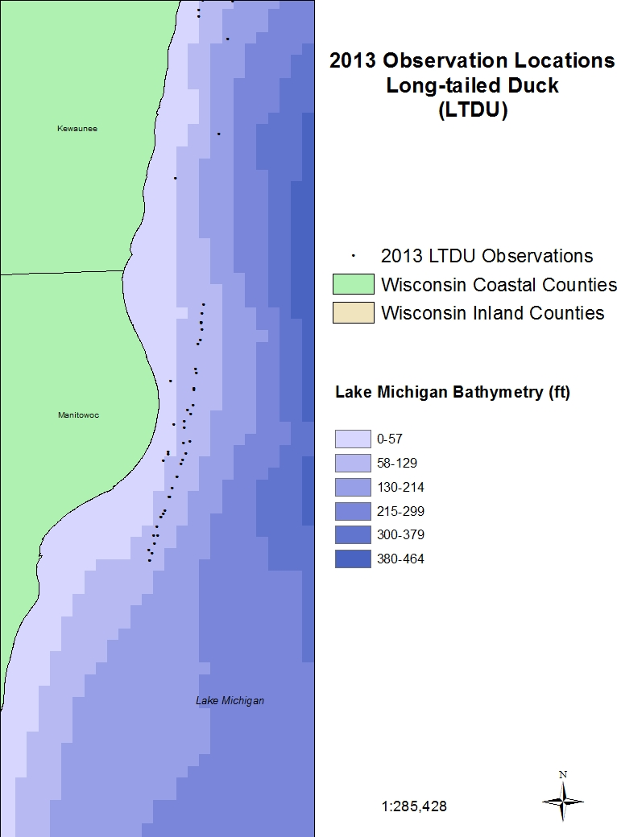

Map 22 – LTDU – Late Fall 2013

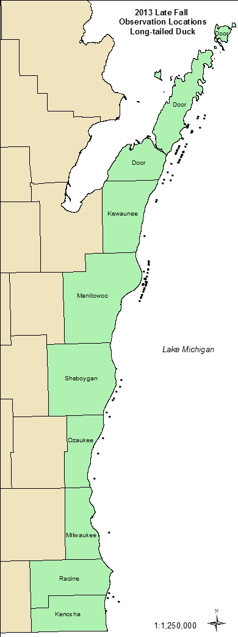

Map 23 – Fall 2013 – Graduated Circle Map - LTDU

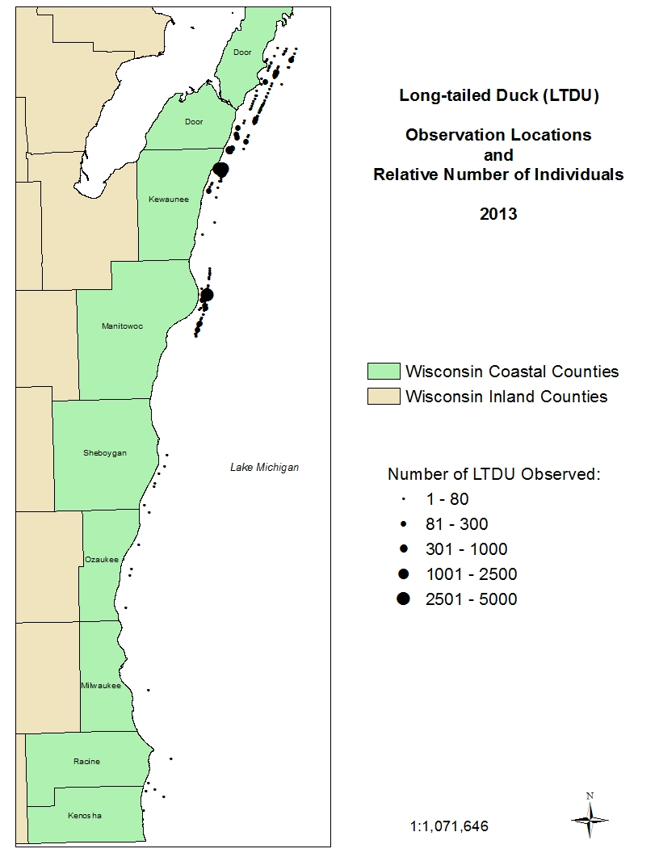

Map 24 – Early Fall 2013 - RBME

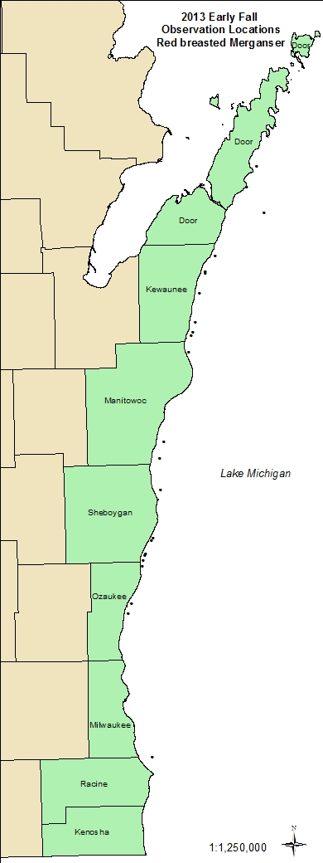

Map 25 Fall 2013 – RBME – Graduated Circle Map

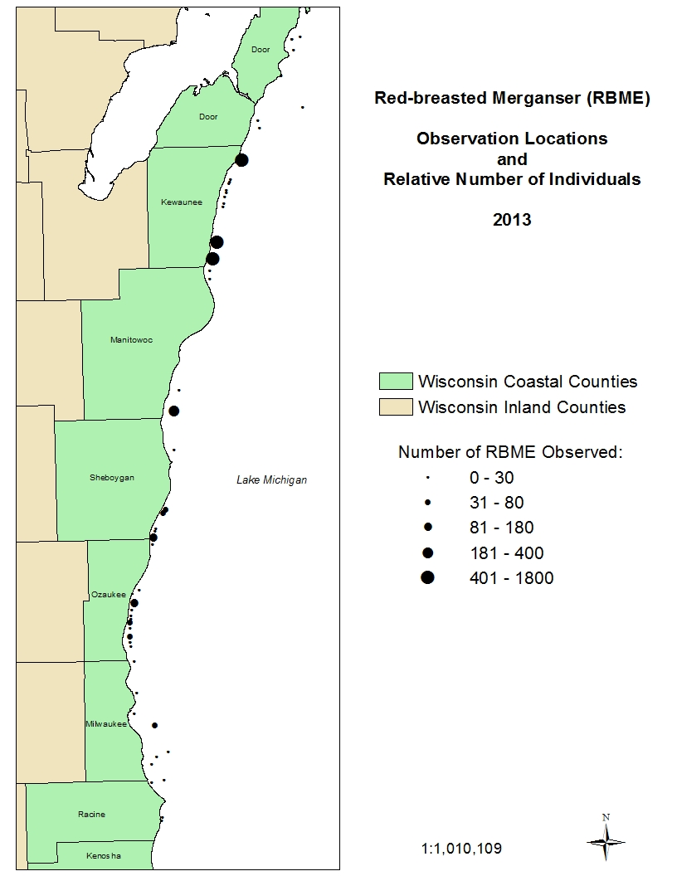

Map 26 – Late Fall 2013 - RBME

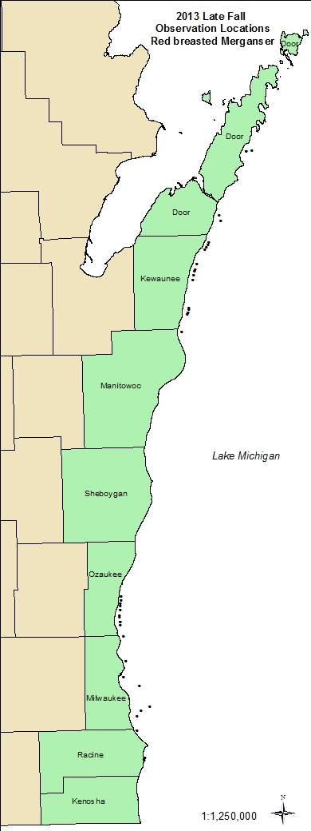

Map 28 –April 2014 – Most Abundant Species – Northern Counties

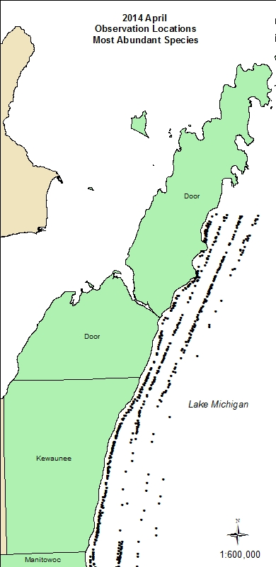

Map 29 –April 2014 – Most Abundant Species

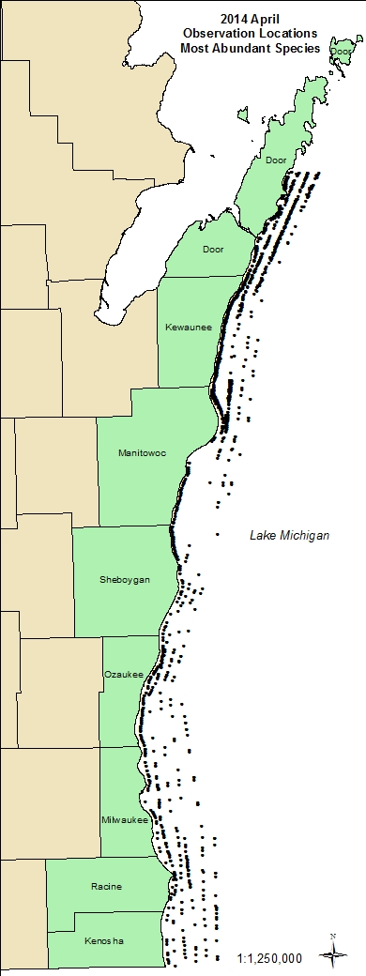

Map 30 – April 2014 – Most Abundant Species - Kewaunee through Sheboygan Survey Areas

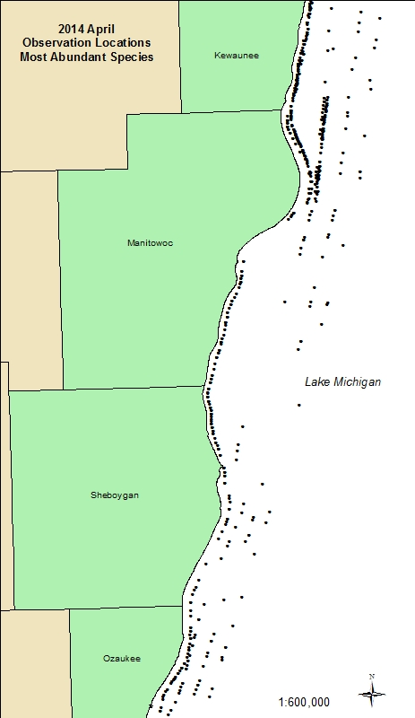

Map 31 – April 2014 – Most Abundant Species – Mid-Lakeshore

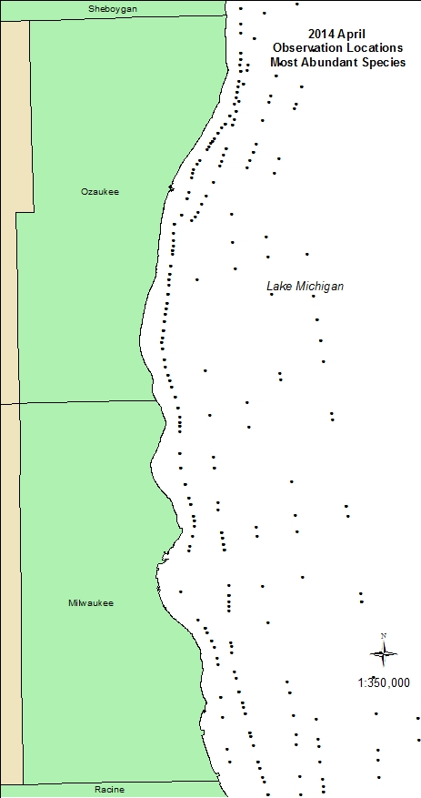

Map 32 – April 2014 – Most Abundant Species – Southern Counties

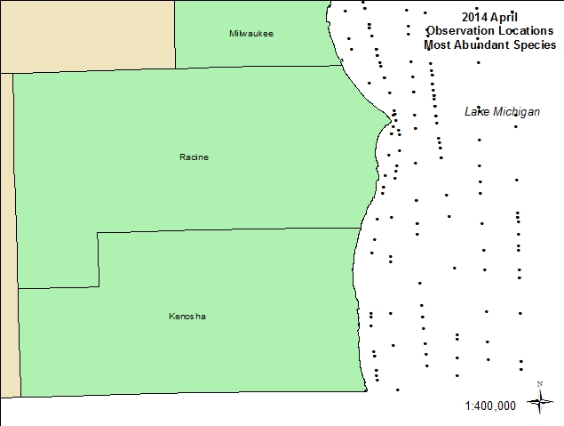

Map 33 – April 2014 – Bonaparte’s Gull

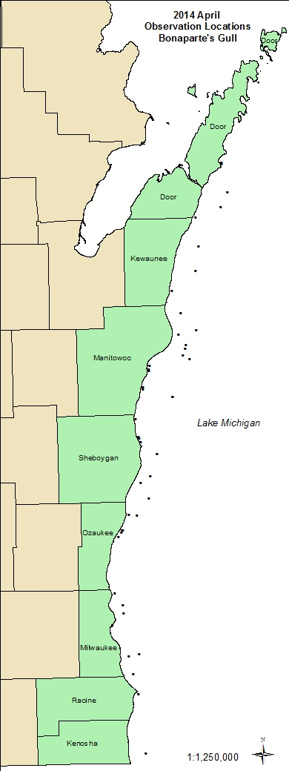

Map 34 – May 2014 – Bonaparte’s Gull

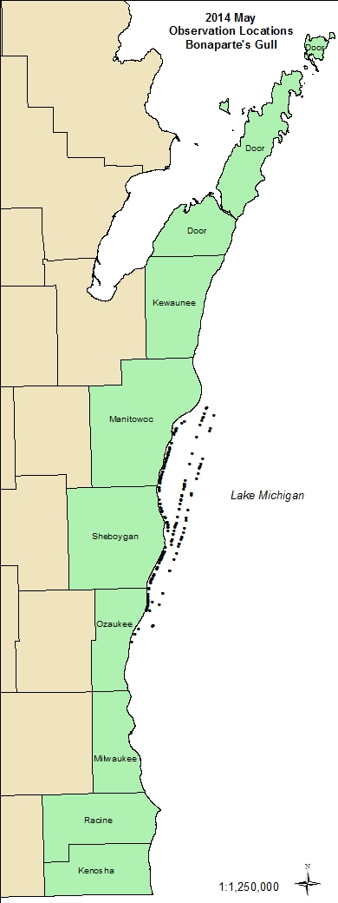

Map 35 – April 2014 – Common Goldeneye

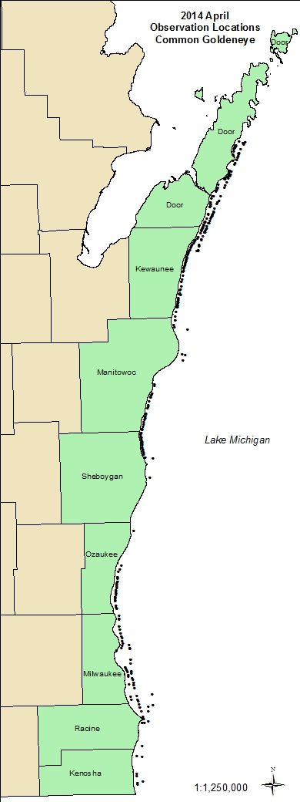

Map 36 – March 2014 – Common Goldeneye

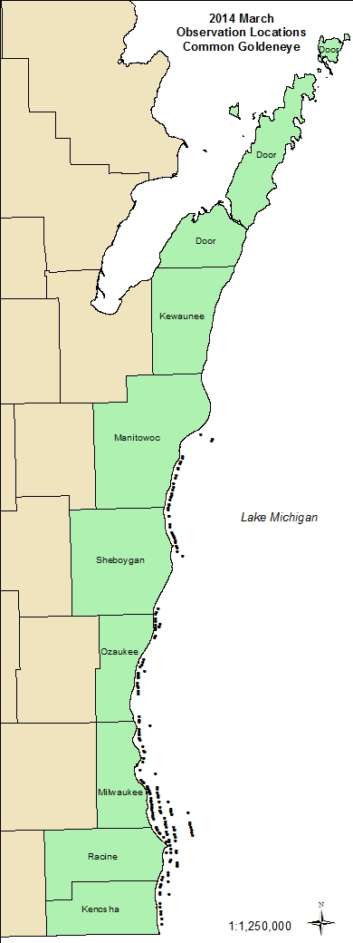

Map 37 – Unknown Duck Species - April 2014

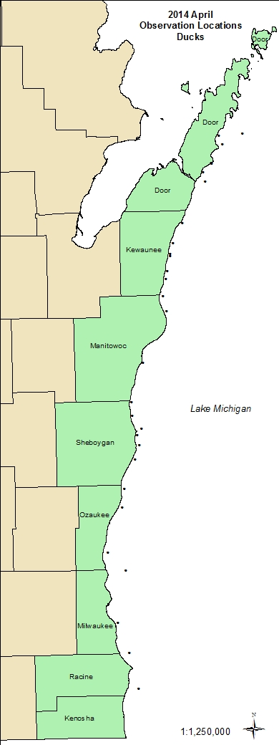

Map 38 – Gull Species (POOLED) – April 2014

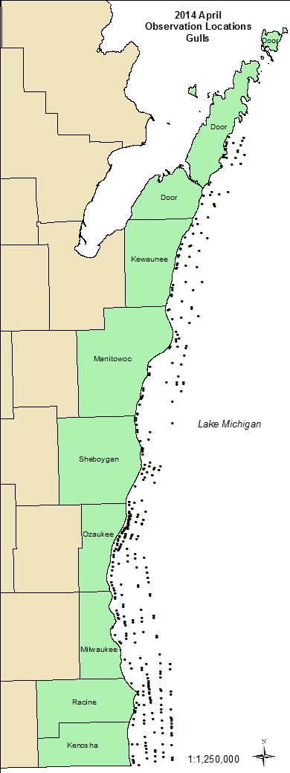

Map 39 – March 2014 – Gulls (POOLED)

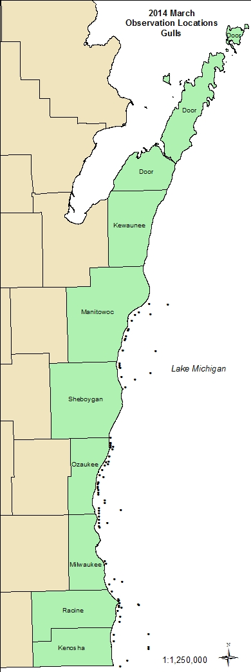

Map 40 – May 2014 – Gulls (POOLED)

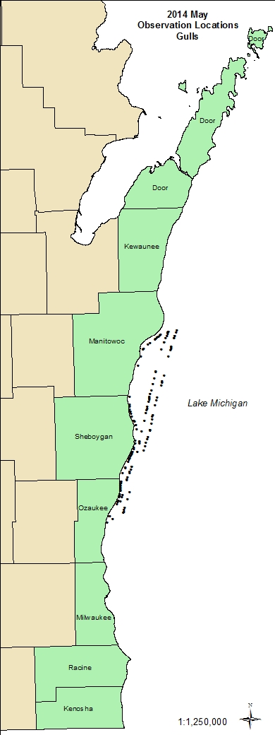

Map 41 – Loons (Pooled) – April 2014

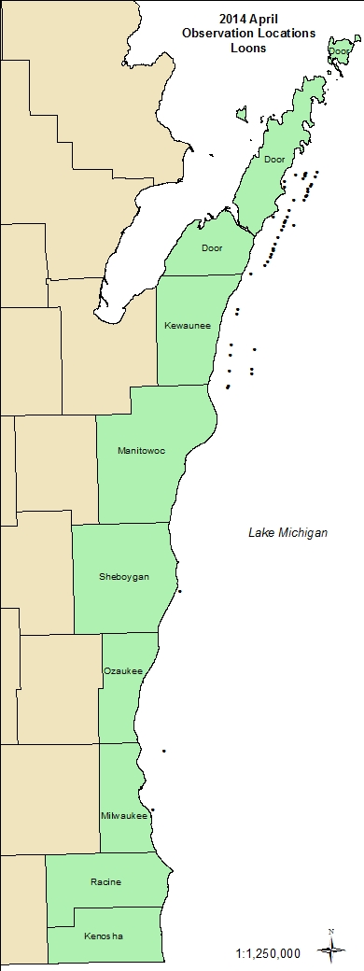

Map 42 – April 2014 - LTDU

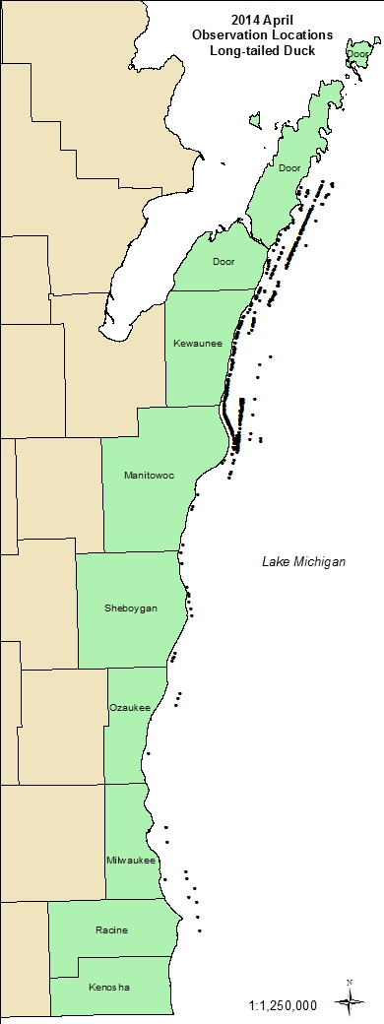

Map 43 – Spring 2014 – LTDU and Bathymetry

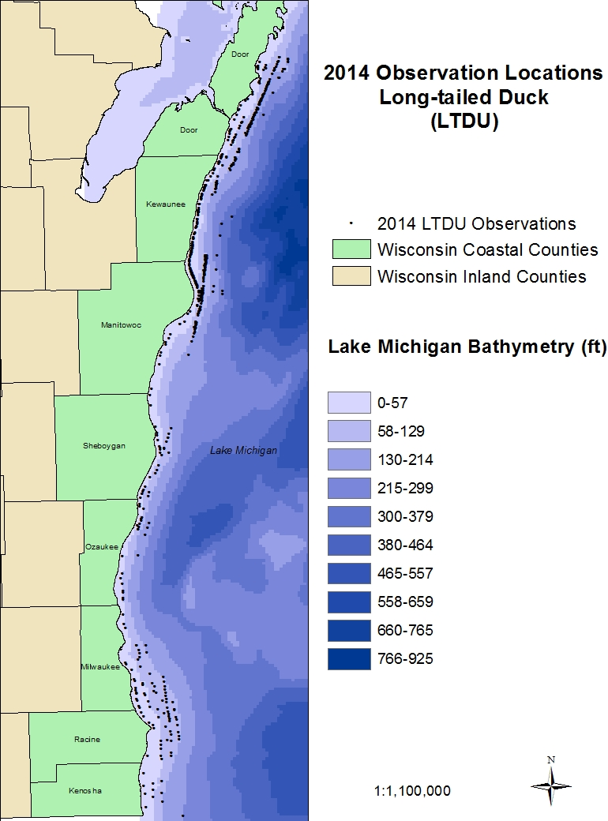

Map 44 – Mid-Lakeshore – LTDU – Spring 2014

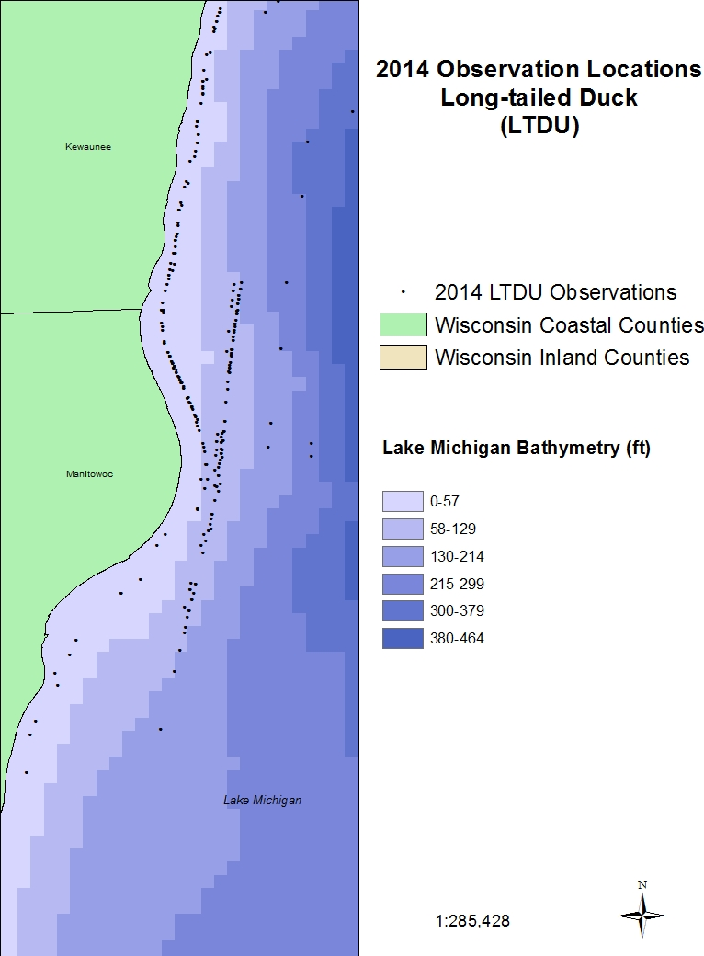

Map 45 – March 2014 – LTDU

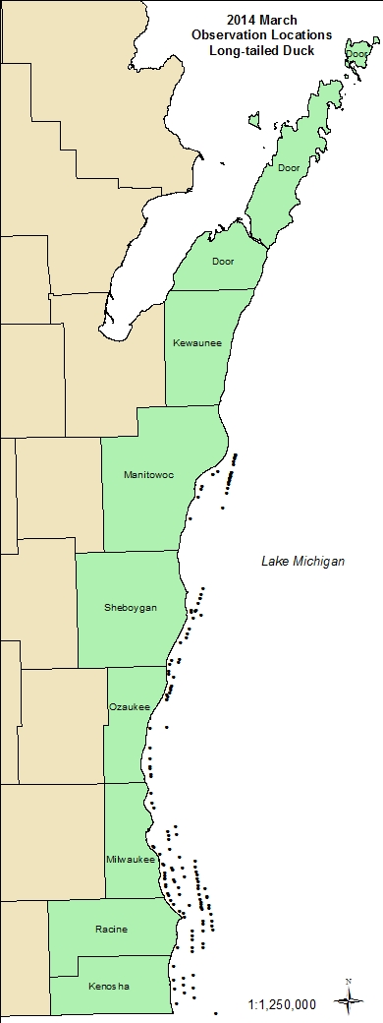

Map 46 – March 2014 – Most Abundant Species

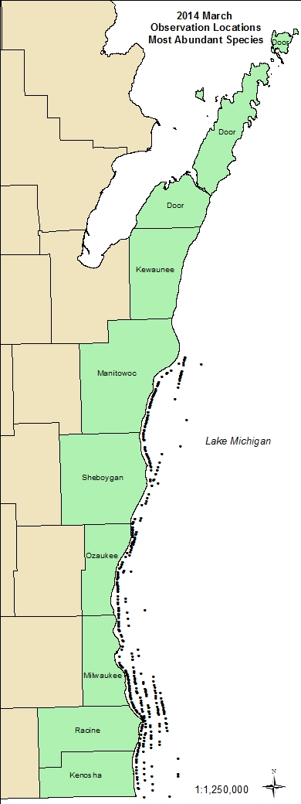

Map 47 – March 2014 – Most Abundant Species – Mid-Lakeshore

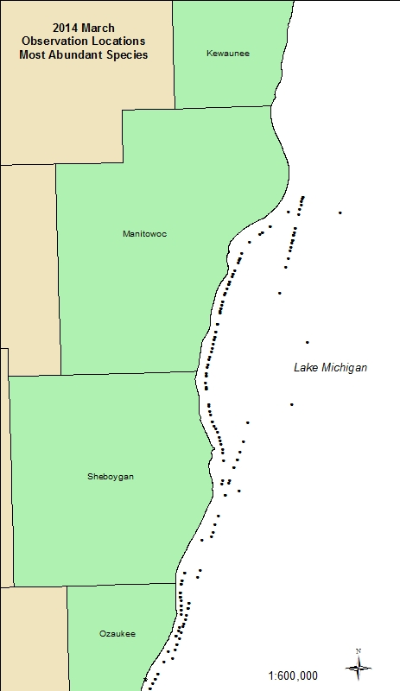

Map 48 – March 2014 – Most Abundant Species – Ozaukee/Milwaukee

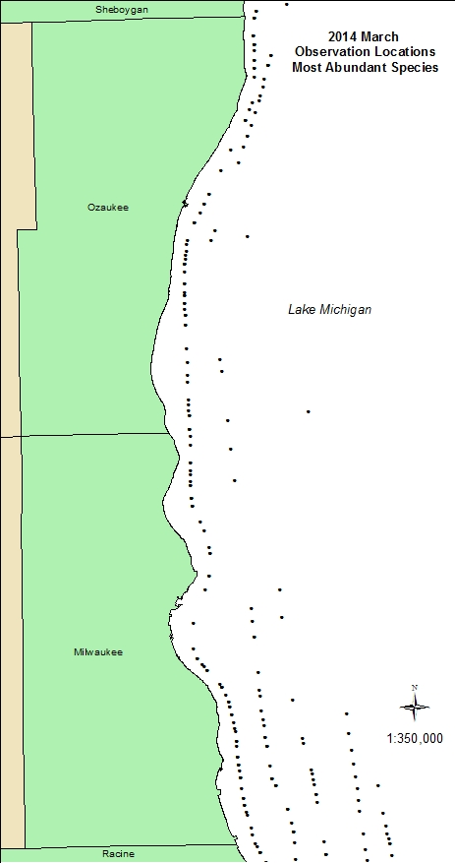

Map 49 – March 2014 – Most Abundant Species – Southern Counties

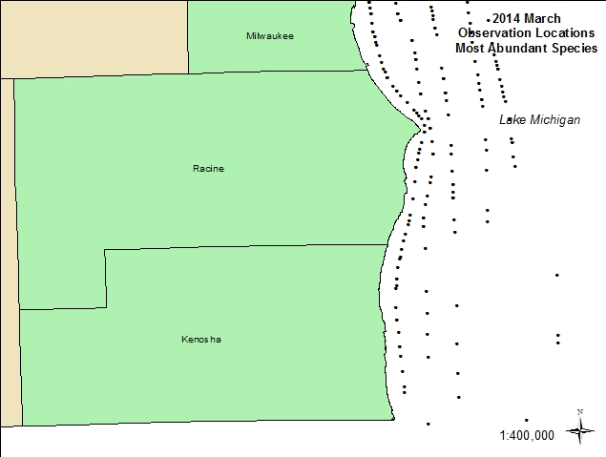

Map 50 – May 2014 – Most Abundant Species

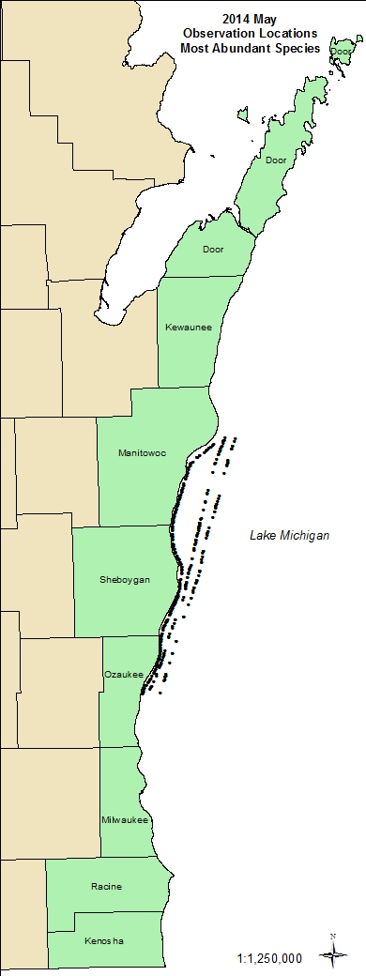

Map 51 – May 2014 – Most Abundant Species – Mid-Lakeshore

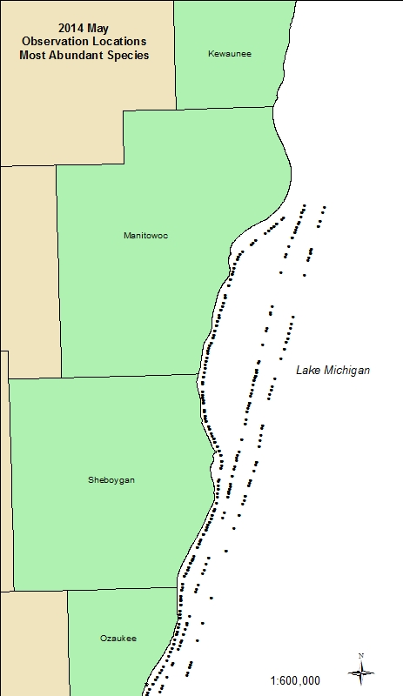

Map 52 – May 2014 – Ozaukee/Milwaukee – Most Abundant Species

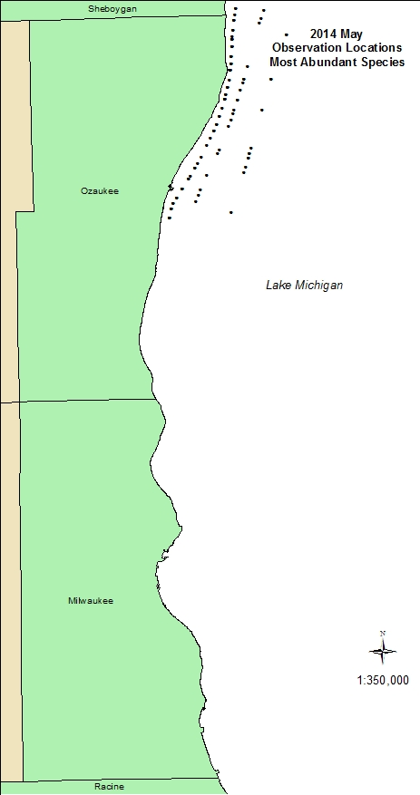

Map 53 – April 2014 – RBME -

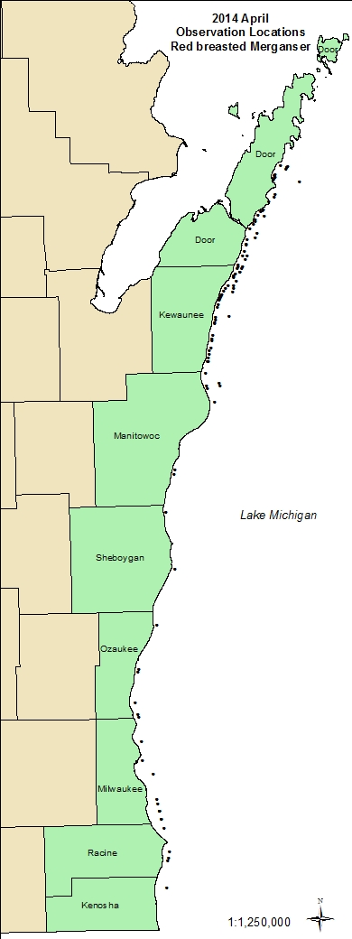

Map 54 – May 2014 - RBME

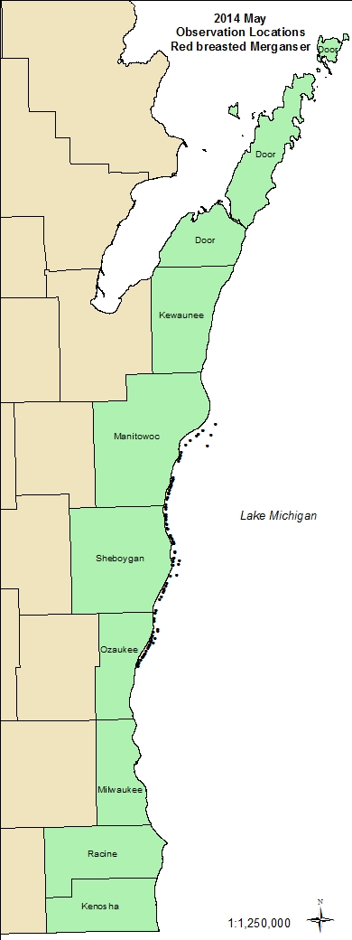

Map 55 – April 2014 – Scaup, Sp.

